1:GENERATE NO OF SERIES:

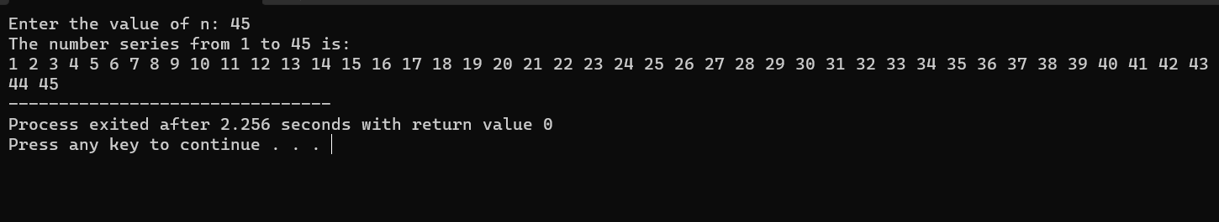

2:EVEN SERIES:

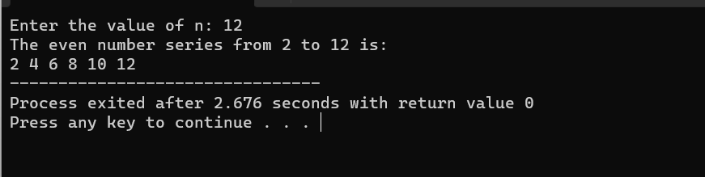

3:ODD NUMBER SERIES:

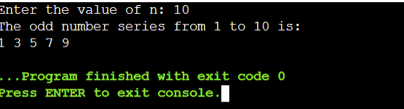

4:FIBONNACCI SERIES:

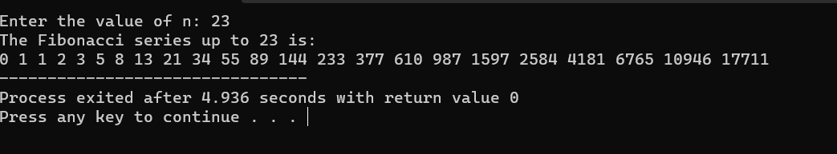

5: Summing up series 1 + 2 + 3 + 4….. +n

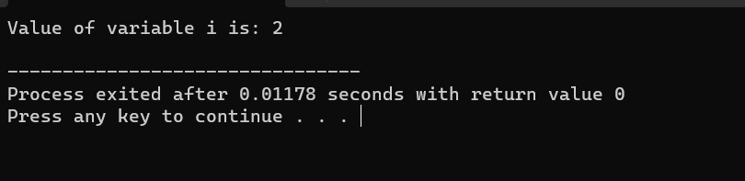

6: Summing up Even Number series:

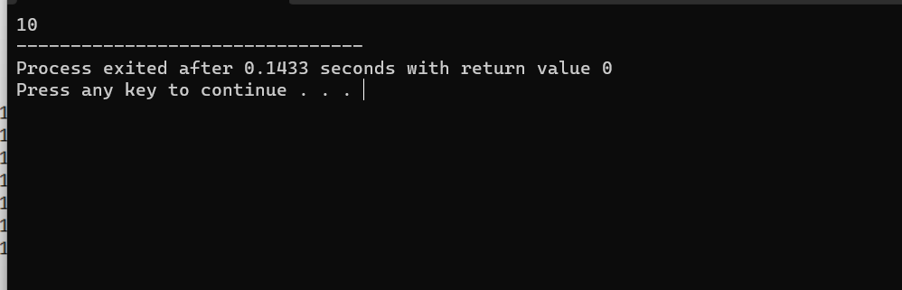

7:

7: Summing up Odd Number series:

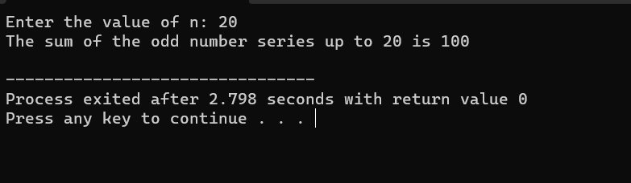

8: Summing up 1 – 2 + 3 – 4 + 5…. N:

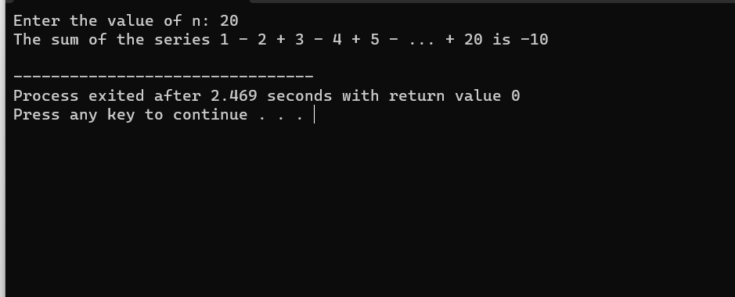

9: Summing up 12 + 22 + 32 + 42….. +n:

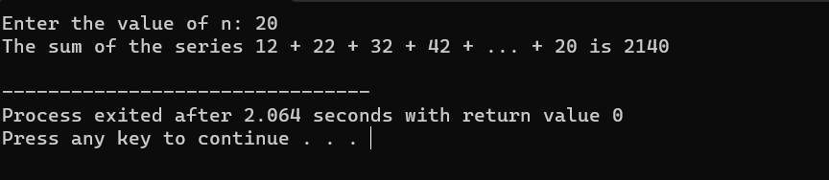

10:Summing up 22 + 42 + 62 + 82 + ….. n2:



11: Summing up 11+22+33+44+ …. Nn:

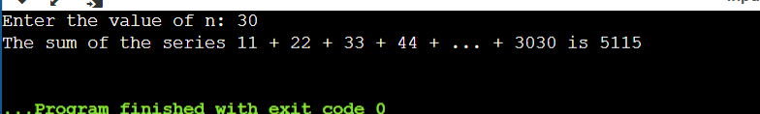

12: Summing up squares of Odd numbers:

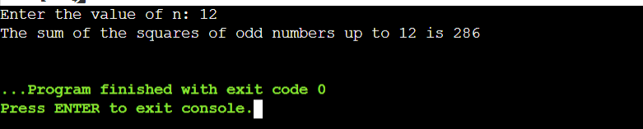

13: Summing up cubes of n numbers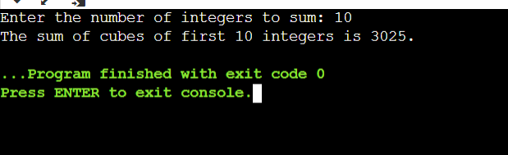

14: Product series (Factorial of a given number):

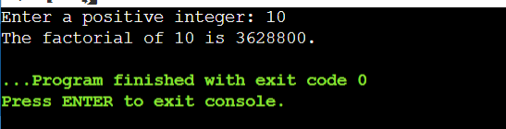

15: Finding given number is Armstrong or not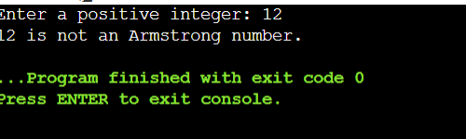

16: Summing up any n numbers and finding average:

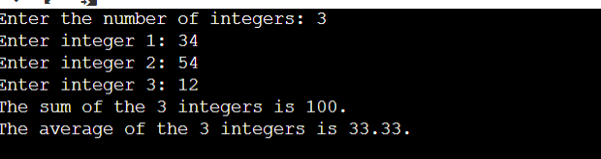

17: Printing digits of an integer number:

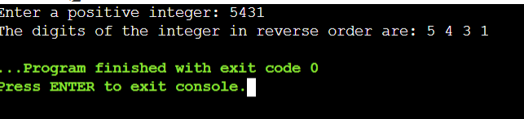

18: Summing up the digits of an integer number:

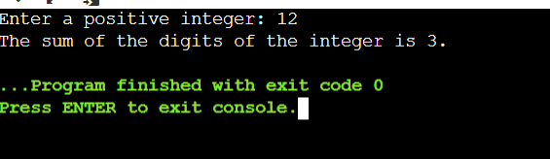

19: Revering the digits of an integer number:

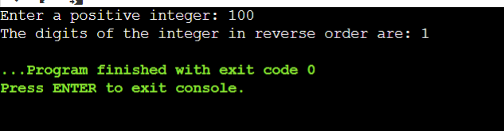

20: Finding whether the given integer is odd or even:

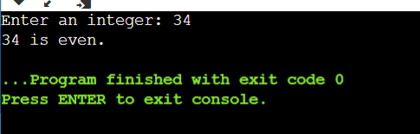:

21: Finding the given integer is positive or negative:

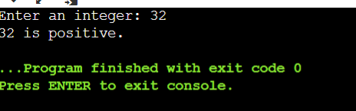

22: Swapping two numbers with a temporary variable:

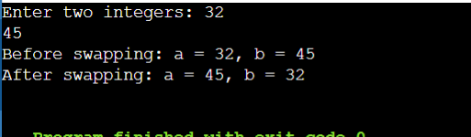

23: Swapping two numbers without a temporary variable:

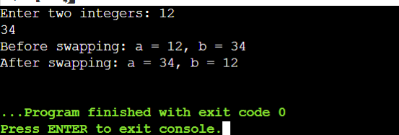

24: Swap 3 numbers a to b, b to c and c to a:

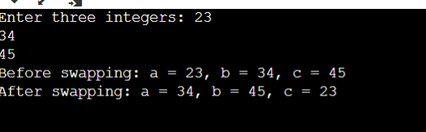

25: Finding the biggest out of 2 integer numbers in c:

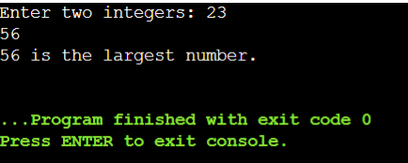

26: Finding the biggest out of n integers:

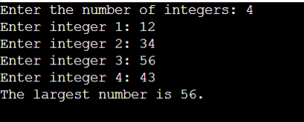

27: Sine series [sin(x) = x - x 3 /3! + x 5 /5! - x 7 /7! . . . . . . ]:

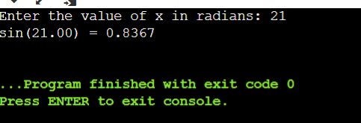

28: Cos series [cos(x) = 1 – x 2 /2! + x 4 /4! – x 6 /6! . . . . . . ]:

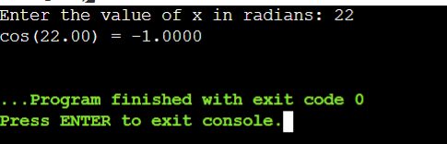

29: Exponential series [e -1 = 1 – x/1! + x 2 /2! – x 3 /3! + x4 /4! . . . . . . ]:

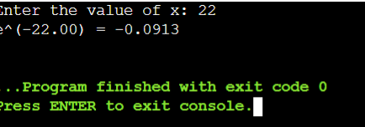

30: Linear Search

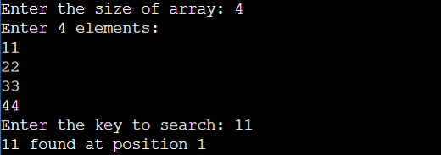

31: Calculate the water bill given the cubic feet of water used for Eureka Water Company, which charges the homeowner one of the following: a. A flat rate of $15.00 for usage up to and including 1000 cubic feet. b. $0.0175 per cubic foot for usage over 1000 cubic feet and up to and including 2000 cubic feet. c. $0.02 per cubic foot for usage over 2000 cubic feet and up to and including 3000 cubic feet. d. A flat rate of $70.00 for usage over 3000 cubic feet. Write the algorithm, draw the flowchart and write pseudocode to test the above problem.

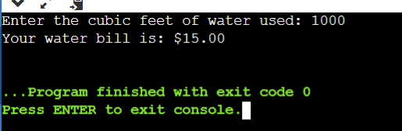

32: A company that issues check-cashing cards uses an algorithm to create card numbers. The algorithm adds the digits of a four-digit number, and then adds a fifth digit of 0 or 1 to make the sum of the digits even. The last digit in the number is called the check digit. Complete the seven problem-solving steps to develop a solution that accepts a four-digit number into one variable, adds the check digit, and prints the original number and the new number. Test your algorithm, flowchart and pseudocode with the following data: Original (47371) and 4631 (46310). Hint: You may use any or all of these functions and the principle of concatenation of strings. Integer(X)—Integer function String(X)—Numeric to string Value(A)—String to numeric Note: The Integer(X) gives the whole number value of the real number X. When X is 546.43, the Integer(X) is 546; when X is 23.899 the Integer(X) is 23. The String(X) and Value(A) are conversion functions. The resultant of the function String(X) is the string value of the numeric X. The resultant of Value(A) is the numeric value of the string A. Concatenation is the combining of strings by placing the first string in front of the second one. For example, the resultant of would be “45.”

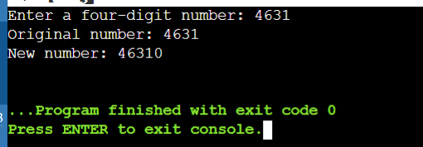

33: An admission charge for The Little Rep Theatre varies according to the age of the person. Develop a solution to print the ticket charge given the age of the person. The charges are as follows: a. Over 55: $10.00 b. 21–54: $15.00 c. 13–20: $10.00 d. 3–12: $5.00 e. Under 3: Free:

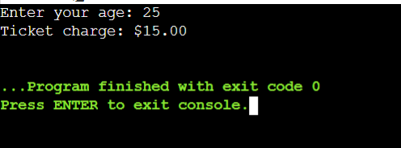

34: A hotel has a pricing policy as follows: a. 2 people: $85 b. 3 people: $90 c. 4 people: $95 d. Additional people: $6 per person If the customer is staying on company business, there is a 20% discount. If the customer is over 60 years of age, there is a 15% discount. A customer does not receive both discounts. Given the above data, print the cost of the room.

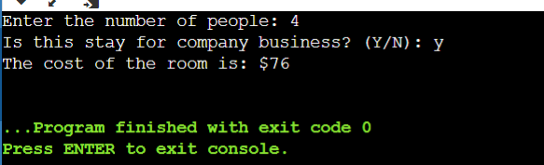

35: A student wants to know his grade point average for the semester. The grades are given in letter grades with numeric equivalents. Develop a solution to calculate a grade point average given the letter grades. (Remember, the grade point average is figured per unit of credit, not per course.) An A = 4.0, B = 3.0, C = 2.0, D = 1.0, F = 0.0. Write the algorithm to test the solution with the following data and draw flowchart and write pseudocode: History B 3 units Economics A 3 units PE A 1 unit Chemistry C 4 units Art B 3 units

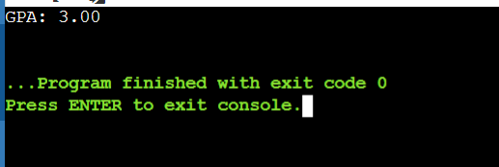

36: Mr. Johnson would like to know how many As, Bs, Cs, Ds, and Fs his students received on a test. He has 200 students who took the test. He would like to enter the student number and the number grade for the test for each student. Develop the solution to print out each student’s student number, number grade, letter grade, and the total number of As, Bs, Cs, Ds, and Fs. His grading scale is as follows: 90–100 is an A, 78–89 is a B, 65– 77 is a C, 50–64 is a D, and below 50 is an F. Write the algorithm, draw the flowchart and write pseudocode to test the above problem.

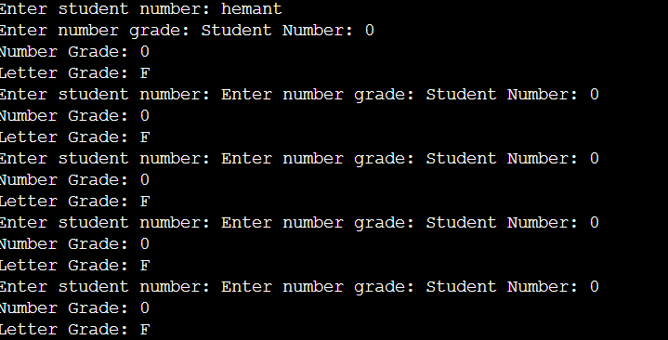

37: . John Smith is a new car salesperson. Write the algorithm to calculate the total cost of a car given the following. In Addition, write the pseudocode and draw the flowchart: initial price of the car 0 to 10 accessories (the computer would select the price according to the accessory) sales tax

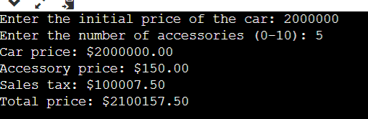

38: The Last Stop Boutique is having a five-day sale. Each day, starting on Monday, the price will drop 10% of the previous day’s price. For example, if the original price of a product is $20.00, the sale price on Monday would be $18.00 (10% less than the original price). On Tuesday the sale price would be $16.20 (10% less than Monday). On Wednesday the sale price would be $14.58; on Thursday the sale price would be $13.12; and on Friday the sale price would be $11.81. Develop a solution that will calculate the price of an item for each of the five days, given the original price. Write the algorithm, flowchart and pseudocode to test the solution. 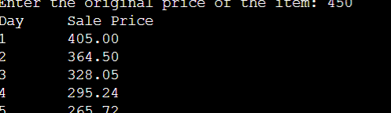

39: Mary Smith, a student, has borrowed $3,000 to help pay her college expenses. After setting up a budget, $85 was the maximum monthly payment she could afford to make on the loan. Develop a solution to calculate and print the interest, the principal, and the balance on the loan per month. Other information she would like to know is the number of years and months it will take to pay the loan back and the total interest she will pay during that period. The interest rate is 1% per month on the unpaid balance. Write the algorithm, flowchart and pseudocode to test the solution.

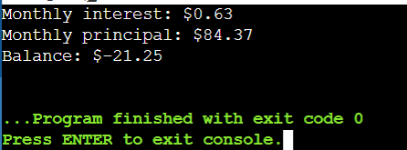

40: Write a solution (algorithm, flowchart and pseudocode) to find the average miles per gallon on a car after six fillups at a gas station. Additional data kept included the number of gallons of gas at each fillup, the starting odometer reading, and the odometer reading at each fillup.

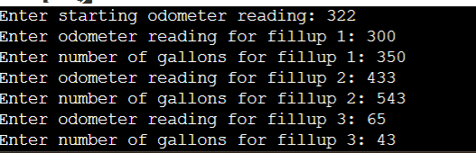

41: Develop a solution (algorithm, flowchart and pseudocode) to calculate a student’s grade average for one semester. The letter grades should be entered and the grade average printed out. An A is equivalent to 4 grade points, a B is 3 grade points; a C is 2 grade points, a D is 1 grade point, and an F is zero grade points.

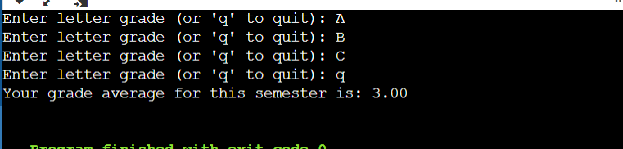

42: Mr. Jones always gives True/False tests to his class. His tests always have 20 questions. The maximum class size is 35. He needs a program that will calculate the students’ rades based on the best score. Grade A will range from the best score, to the best score minus 2. B will range from the best score minus 3, to the best score minus 4. C will range from the best score minus 5, to the best score minus 6. D will range from the best score minus 7, to the best score minus 8. F will be anything below the best score minus 8. Each student’s ID and test answers will be entered. The output will be each student’s ID, number correct, and grade, along with the single highest score for the class. Develop the algorithm, draw the flowchart and write the pseudocode for Mr. Jones’s problem. Use four one-dimensional arrays—one for the correct scores and the other three for the needed output.

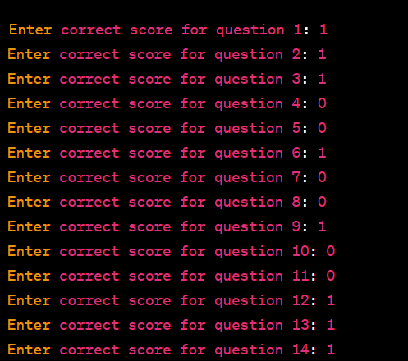

43: A restaurant manager wants to know how many employees are needed at the restaurant each hour of the day. The minimum number of employees needed at any hour is 3. After that, one additional employee is required for each 20 customers. The restaurant is open 24 hours a day. The manager has counted the number of customers each hour for 14 days. The manager will use the average number of customers for each hour over the 14 days to calculate the needed number of employees for each hour. Develop an algorithm, draw the flowchart and write the pseudocode output the needed number of employees per hour. (There is no such thing as a partial employee.)

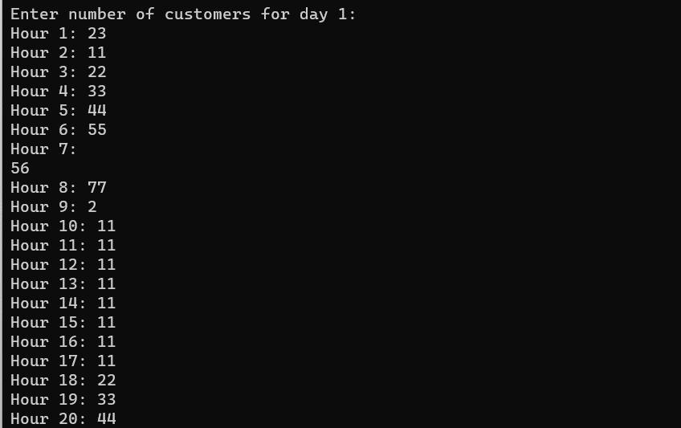44: A company has 10 salespeople. The manager needs to know the average dollar amount of sales for each salesperson for a week, and the total dollar amount of sales for the store for each day and for the week. The store is open 7 days a week, and each salesperson gets 2 days off. The data are entered into a two-dimensional array with the days of the week as the columns and the salespeople as the rows. Develop an algorithm, draw the flowchart and write the pseudocode to output the needed information.

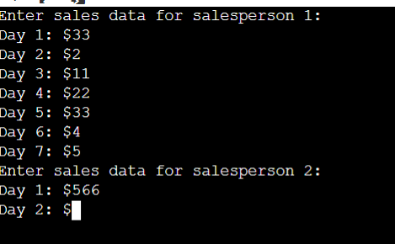

45: An instructor has a class of 25 students. Each student is identified by a number from 1 to 25. All tests are stored in a two-dimensional array, with each column containing the grades for each test. The instructor would like to enter the student number and the test number and have the grade for that test printed on the monitor. Develop an algorithm, draw the flowchart and write the pseudocode to output the needed information.

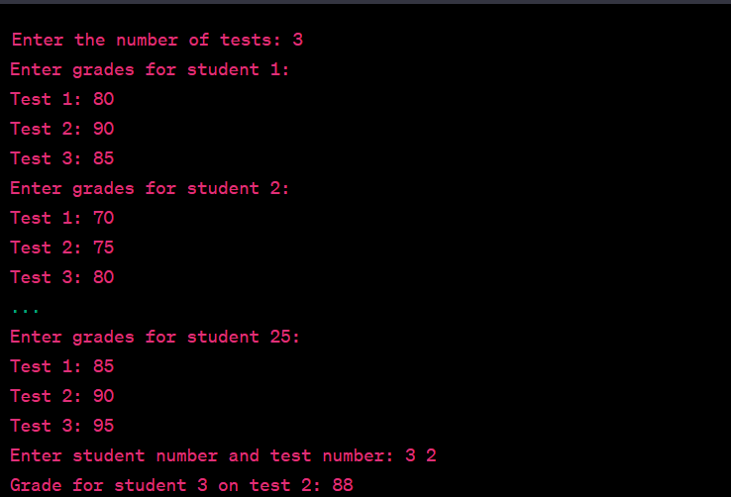

46: The student names and the grades for four tests for Mr. Smith’s class have been placed in parallel arrays. Mr. Smith would like to have one student’s name and test scores printed. Develop an algorithm, draw the flowchart and write the pseudocode that will enter the student’s name, search for the name in the same array, and then print the name and test scores. Use the sequential-search method.

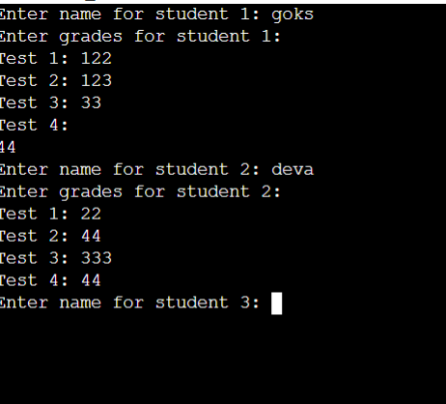

47: The human resources manager of XYZ Corporation would like to analyze the following characteristics of company employees: a. the wages of women compared with those of men b. the total number of employees in each of the 12 departments c. the number of women and men in each of the 12 departments d. the average age of the women and men in each department Develop an algorithm, draw the flowchart and write the pseudocode for this problem

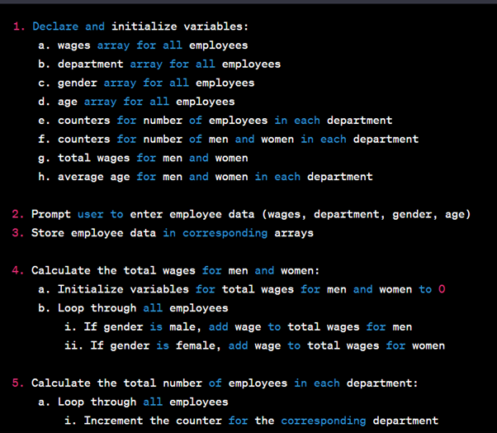

48: A questionnaire was sent to a random selection of the alumni of a college. In all, 95 questionnaires were returned. The questionnaire requested the following items: age gender marital status college major salary The administration would like to know the average salary, given any two sets of items. Develop an algorithm, draw the flowchart and write the pseudocode to cross-tabulate the items and output the needed information. (Remember, the computer cannot divide by zero.)

Here is the pseudocode to cross-tabulate the items and output the average salary given any two sets of items:

1. Initialize variables:
   * age_sum, age_count, gender_count, major_count, salary_sum, num_questionnaires = 0
   * avg_salary = 0
2. Read in the data from the questionnaires:
   * For i = 1 to 95
     + Read in age[i], gender[i], marital_status[i], college_major[i], salary[i]
     + Increment the corresponding count variables:
       - If gender[i] is "M", increment male_count
       - If gender[i] is "F", increment female_count
       - Increment the count for the corresponding college major
3. Prompt the user to enter the two sets of items to cross-tabulate:
   * Prompt for the first set of items (age, gender, marital status, or college major)
   * Prompt for the second set of items (age, gender, marital status, or college major)
4. Calculate the average salary for the selected sets of items:
   * For i = 1 to 95
     + If the questionnaire matches the selected sets of items, add the salary to salary_sum and increment the count
   * If count is greater than 0, calculate the average salary (salary_sum / count)
   * Otherwise, set avg_salary to 0
5. Output the average salary for the selected sets of items:
   * If avg_salary is greater than 0, output the average salary
   * Otherwise, output an error message that no data was found for the selected sets of items
6. End the program

49: A university has four undergraduate class levels and a graduate school. There are 7 majors, although not all students have chosen a major. There are 1,200 students attending the university. The administration would like to know how many students are in each level, and how many students have each major. They also would like to know how many of each class level have declared each major. Develop an algorithm, draw the flowchart and write the pseudocode to output the needed information.

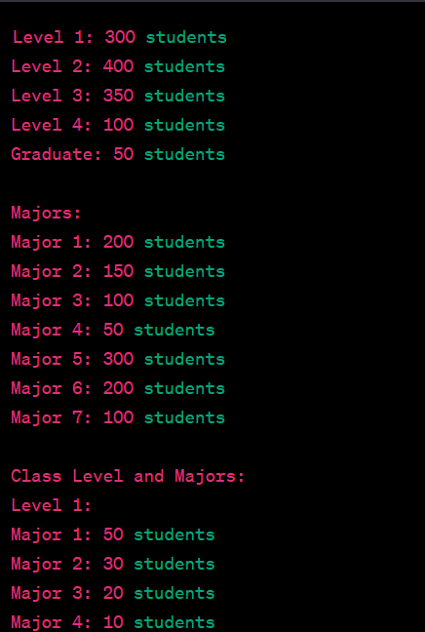

50: John has a weather station in his house. He has been keeping track of the fastest wind speed for each day for two weeks. He would like to know the average wind speed over the two weeks, the days on which the highest wind speed and the lowest wind speed were recorded, and the difference between the highest wind speed recorded and each day’s average wind speed.

